***i***

•

Deepali Rajendra Zelte (210541281038)

•

Pooja Sharad Wayal (210541281135)

**Team Members:**

1

release

00

28-09-2021

Team-19

st

**CHANGE**

**By**

**Version**

**DATE**

**REASON FOR**

**Authored By**

**Reviewed**

**Revision History:**

**IACSD, Akurdi**

**[28-09-2021]**

**Inhouse Services**

**SOFTWARE REQUIREMENT SPECIFICATION FOR**

IACSD Akurdi

In House Services

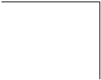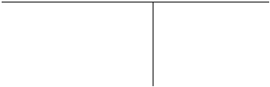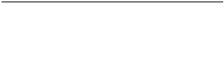

Patil Sir

***ii***

**6.**

**Other Requirements ......................................................................................................................... 8**

Business Rules .........................................................................................................................................7

Software Quality Attributes ....................................................................................................................7

Security Requirements ............................................................................................................................6

Safety Requirements................................................................................................................................6

Performance Requirements .....................................................................................................................6

**5.**

**Other Non-functional Requirements ............................................................................................. 6**

System Feature 2 (and so on)..................................................................................................................6

System Feature 1 .....................................................................................................................................5

**4.**

**System Features ................................................................................................................................ 5**

Communications Interfaces ....................................................................................................................5

Software Interfaces ..................................................................................................................................5

Hardware Interfaces ................................................................................................................................5

User Interfaces .........................................................................................................................................5

**3.**

**External Interface Requirements ................................................................................................... 5**

Assumptions and Dependencies .............................................................................................................4

User Documentation ................................................................................................................................4

Design and Implementation Constraints ................................................................................................4

Operating Environment ...........................................................................................................................3

User Classes and Characteristics ............................................................................................................3

Product Functions ....................................................................................................................................3

Product Perspective .................................................................................................................................2

**2.**

**Overall Description ........................................................................................................................... 2**

References ................................................................................................................................................1

Product Scope ..........................................................................................................................................1

Intended Audience and Reading Suggestions........................................................................................1

Document Conventions ...........................................................................................................................1

Purpose .....................................................................................................................................................1

**1.**

**Introduction ....................................................................................................................................... 1**

**Table of Contents**

IACSD Akurdi

In House Services



***1***

document contains functionalities and characteristics of system along with the working

purpose of understanding the design of system in terms of different perspectives. Further, this

This document is intended for developers, users, testers and project managers for the

**1.3 Intended Audience and Reading Suggestions**

Highlighting: - Times New Roman

Text: - Simple Font-Size: -10

**Footer: -**

Highlighting: - Times New Roman

Text: - Simple Font-Size: -10

**Header: -**

Highlighting: - Times New Roman

Text: -Bold Font-Size: - 12

**Sub Headings: -**

Highlighting: - Times New Roman

Text: -Bold Font-Size: - 14

**Headings: -**

**1.2 Document Convention**

to their time to get their job done. 

•    In this project customer can hire employee according to their requirements and according

trustworthy people and also to provide instant services to our customers. 

•    The main objective of our project is to provide job to unemployed ,talented,

**1.1 Purpose**

**1. Introduction**

IACSD Akurdi

In House Services



***2***

any bargaining and without going outside the home.

application customer can instantly hire the professional according to their work and without

contractor and there is some procedure and bargaining is included but using this web

professional workers to find the source of income. Generally, customers’ needs to find some

situation In House Services will help customers to find the workers to do their work and the

find them work and also for customers to find the workers. So, keeping in mind all this

Covid-19 Pandemic badly effects on the income of some workers and it difficult to

friendly user interface so user can easily access all functionalities.

section and their different functionalities. In addition, the application will have the very user-

the product functions section. It includes the Admin, Professionals/Employee and Customers

In House Services will be the web application that provides functionality described in

**2.1 Product Perspective**

**2. Overall Description**

https://docs.oracle.com/javase/tutorial/

https://stackoverflow.com/

https://reactjs.org/docs/

**1.5 References**

at home. 

•    We can empower millions of service professionals across the India to deliver services

etc.

 

Our project consists of lots of category like divers, plumber, painter, evet-planner, maid

•

can easily provide services to users and job to jobless people.

•    Now a day it’s very hard to search trustworthy employee and searching job our project 

**1.4 Product Scope**

requirements, features and other non - functional requirements.

environment. It also includes other information related to system such as external interface

IACSD Akurdi

In House Services



***3***

 

new customer who hired them.

login themselves. They can accept the hiring request. They can see the history of hired list and also the

Professional will be able to register them as professional/employee in particular work area and

**Professional:**

has any complaints about professional/Employee. 

by providing some required information. The customer will be able to post a complaint if he/she

according to the type of work and area. He can instantly hire the worker by clicking on hire button and

Customers will be able to register and login himself and search for the professional workers

**Customer:**

registration. He will be able to see all activities going between customer and worker.

someone report any customer or professional/employee, he will be able to cancel his

This person will be able to see all the details and functionaities from the application. If

**Admin:**

**2.3 User Classes and Characteristics**

 

 

•

By using View Complaint Functionality admin will block that Customer or Employee. 

 

professional/Employee 

•

The customer will be able to post a complaint if he/she has any complaints about

 

•

Admin can see all the professional/employee and customer. 

 

•

The customers can hire the professional/Employee according to their work. 

city they will get a list of professional/Employee workers. 

•

The customers can search according to their requirement and according to their nearby

•

The professional/Employee will be able to select their work area. 

•

The customers will be able to register and login themselves. 

professionals/Employee 

•

The Professionals/Employee will be able to register and login themselves as

**2.2 Product Functions**

IACSD Akurdi

In House Services



***4***

tips for errors and malfunctions; pointers to reference documents; and glossary of terms.

instructions for using the system including conventions, messaging structures, quick references,

purpose and scope of the product along with key system features and operations; step-by-step

considerably. The user manual would follow common user documentation styles capturing

be written for nontechnical individuals and the level of content or terminology would differ

understand the working methodology and usage of the developed prototype system. It would

Along with the web application, a user manual would be written to help people

**2.5 User Documentation**

 

 

•   User can access through any mobile or computer 

•   Limited to HTTP/HTTPS 

•   User can log-in only with his assigned user-name and password 

•   Design of user interface will be very user friendly and simple 

•   User interface is only in English. No other language option is available 

**Constraints:**

**2.4 Design and Implementation Constraints**

 

 

Eclipse Spring Tool Suite (STS)

•   Visual Code Studio, MySQL Workbench ,

**Supported tools:**

•   Back-end: MySQL, J2EE Spring Boot 

•   Front-end: HTML, CSS, Bootstrap, React Js,  

**Software platform:**

 

•  Hard Disk – Free disk space of above 1 GB 

•  RAM – 4 GB or above 

•  Processor – Above Pentium 4, with clock speed of 2.0 GHz 

**Hardware platform:**

**Operating Environment**

IACSD Akurdi

In House Services



***5***

React Js. Data will be communicated between these interfaces accordingly.

MySQL database. The front-end technologies include HTML, CSS, Bootstrap, React and

In software interfaces, Java, Spring will be the back-end technology used along with

**3.3 Software Interfaces**

with mobile devices as well.

space in the memory. In future enhancements, it can be made responsive to be able to work

above P4 with clock speed of 2.0 GHz with 1 GB RAM and the Hard Disk with 1 GB free

In the hardware interface, the system interacts with hardware given the processor is

**3.2 Hardware Interfaces**

Based on the user requirement, user can search for the service and can hire professional.

Admin will track complaint details and other activity and accordingly data will be persisted.

like login pages, home pages of Customer, Admin, Professional/employee and also the

The main element is web-pages using HTML, Recat Js. Multiple interfaces are there

**3.1 User Interfaces**

**3. External Interface Requirements**

 

•    Admin need to see daily report of customer to worker or worker to customer. 

•    Customer should pay worker immediately after the work done. 

•    Worker should respond to customers hiring request. 

•     There is a need of constant feedback from customer to workers to improve their profile. 

**Dependencies:**

•    It is assumed that the user is familiar with an internet browser and smart phones. 

It will be assumed that the users will possess decent internet connectivity. 

•

Since the application is a web-based application there is a need for the internet browser.

•    The system has internet browser installed 

handling the keyboard and mouse.

•    It is assumed that the user is familiar with an internet browser and also familiar with 

**Assumptions:**

**2.6 Assumptions and Dependencies**

IACSD Akurdi

In House Services



***6***

convenience.

to understand. All the options should be present in properly accessible places for user

application should be user friendly with a proper user interface which makes it easy for the user

staff properly and the application should be available for use 24*7 through the server. Also, the

The system should store all the database records of each customer, employee and admin

**5. Performance Requirements**

Customer can register himself. Customer can hire employee on the basis of work.

**4.2.3 Customer**

vacancy constraints.

Employee can register himself. Upload details. Find the appropriate job within organization’s

**4.2.2 Employee**

and activities done by customers and professionals.

Admin can update, delete, modify the details of the employees and track record of complaints

**4.2.1 Administrator**

**4.2 Functional Requirements**

work and without any bargaining and without going outside the home.

using this web application customer can instantly hire the professional according to their

needs to find some contractor and there is some procedure and bargaining is included but

work and the professional workers to find the source of income. Generally, customers’

mind all this situation In House Services will help customers to find the workers to do their

difficult to find them work and also for customers to find the professionals. So, keeping in

Covid-19 Pandemic badly affects the income of some professional workers and it

**4.1 Description**

**4. System Features**

The main communication interface for interacting with the System will be the web Browser.

**3.4 Communications Interfaces**

IACSD Akurdi

In House Services



***7***

The software will be made to handle operations effectively.

**5.3.5 Effectiveness**

The software will be tested for working with multiple users.

**5.3.4 Durability**

The software will be compatible with multiple platforms.

**5.3.3 Compatibility**

The software will be accessible to admin, Customers and Employee.

**5.3.2 Accessibility**

language. The system should run on a variety of hardware.

The system should run on a variety of operating systems that support the JavaScript

**5.3.1 Availability**

**5.3 Software Quality Attributes**

All passwords should be stored as a secure hash of the administrator password.

be protected from attacks and unauthorized access. The interface should be protected from attacks.

according to the need for E.g.: -marks and feedback for mentor, passwords etc. The database should

records should be carried out properly. Only admin staff will have access rights to the student data

constraints required in the database or the application. Transactions regarding student and mentor

All passwords of the administrators should be protected for privacy using whatever

**5.2 Security Requirements**

for such purpose.

servers. If database is hacked by someone and data is deleted a backup server should be present

issued to all students. Student and Mentor records are to be backed up securely across database

passwords of all the admin staff personnel should be changed and new passwords should be

application. In case any admin staff access account is hacked by any intruder, user id and

should be protected for privacy using whatever constraints required in the database or the

All login ids and passwords of the customers, employee and especially admin staff

**5.1 Safety Requirements**

IACSD Akurdi

In House Services



***8***

o **CSS:** Cascading Style Sheet

o **HTML:** Hyper Text Markup Language

o **SQL:** Structured Query Language

o **GUI:** Graphical User Interface

o **SRS:** Software Requirement Specification

**Appendix A: Glossary**

**6.Other Requirements**

other.

customer can blindly trust on our Website. Before hiring anyone. And it builds trust on each

For security purpose every Employee needs to provide the NOC. It indicates that every

**Customer Security**

**5.4**

data access objects that map the database and the business logic code.

the interface and the business logic code. There should be a clear separation between the

The system should be easy to maintain. There should be a clear separation between

**5.3.6 Maintainability**

IACSD Akurdi

In House Services



***9***

 

 

 

1. **Use Case Diagram**

➢ **Appendix B: Analysis Models**

IACSD Akurdi

In House Services



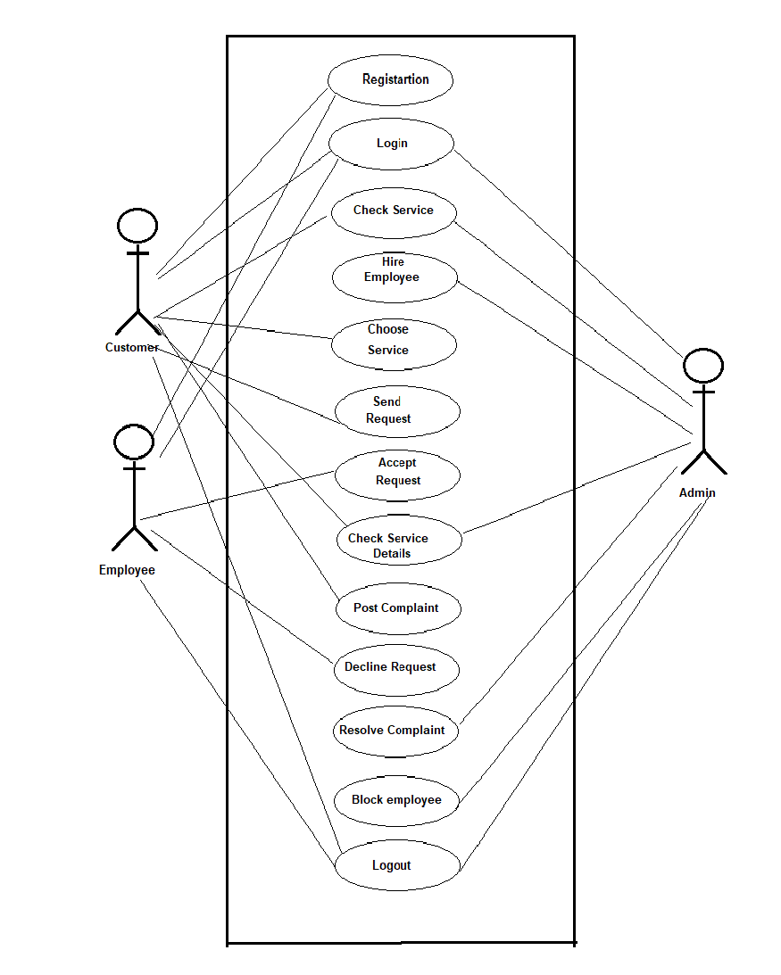

***10***

**ER Diagram:**

IACSD Akurdi

In House Services

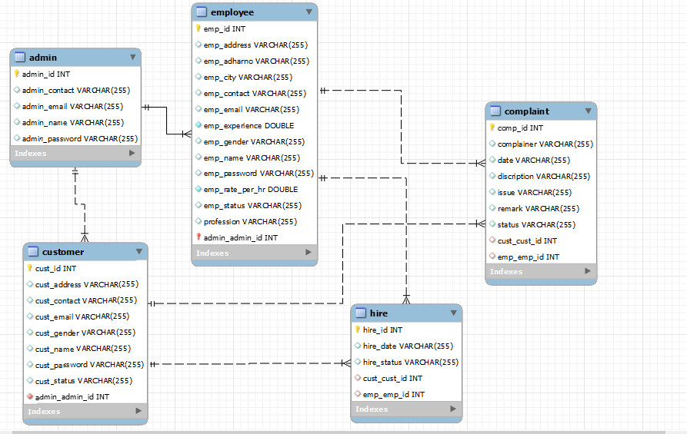

***11***

**a) Class Diagram**

IACSD Akurdi

In House Services

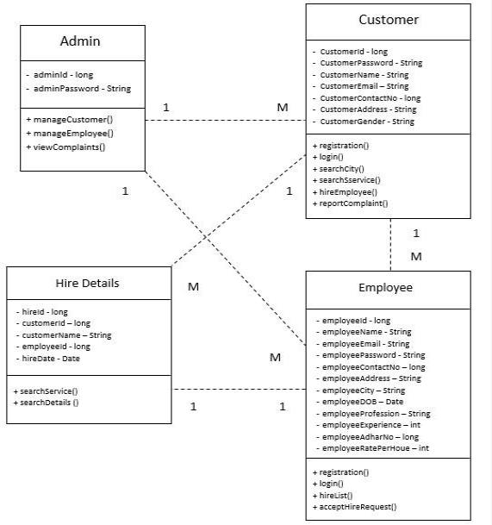

***12***

**Customer Activity Diagram: c.1**

**b)**

**Activity Diagram**

IACSD Akurdi

In House Services

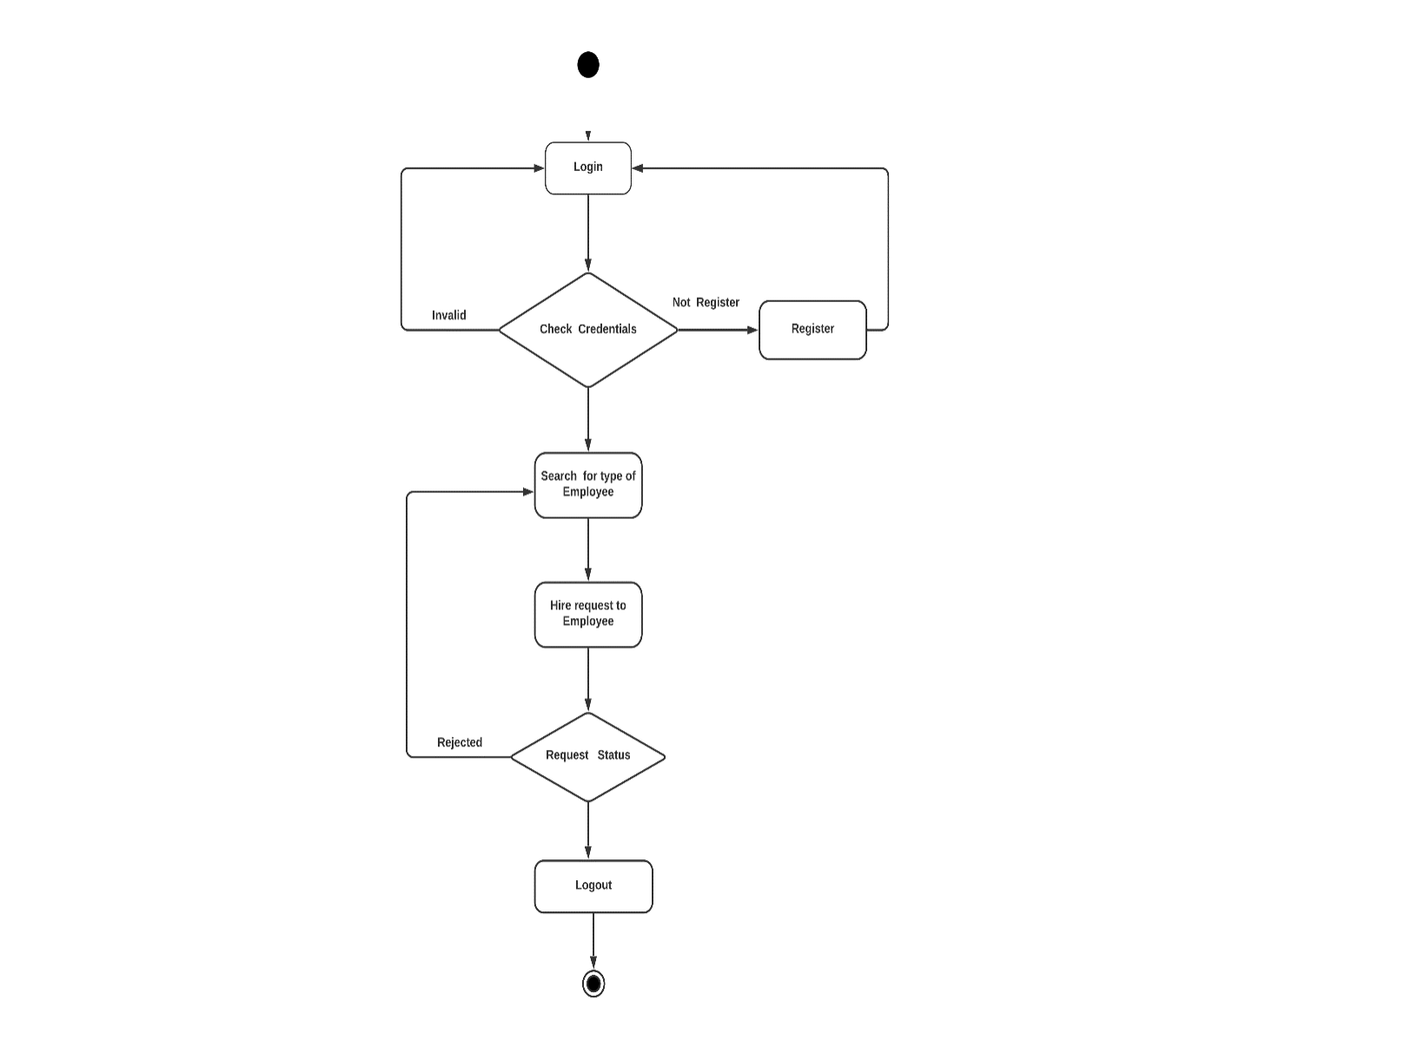

***13***

**Employee Activity Diagram: c.2**

IACSD Akurdi

In House Services

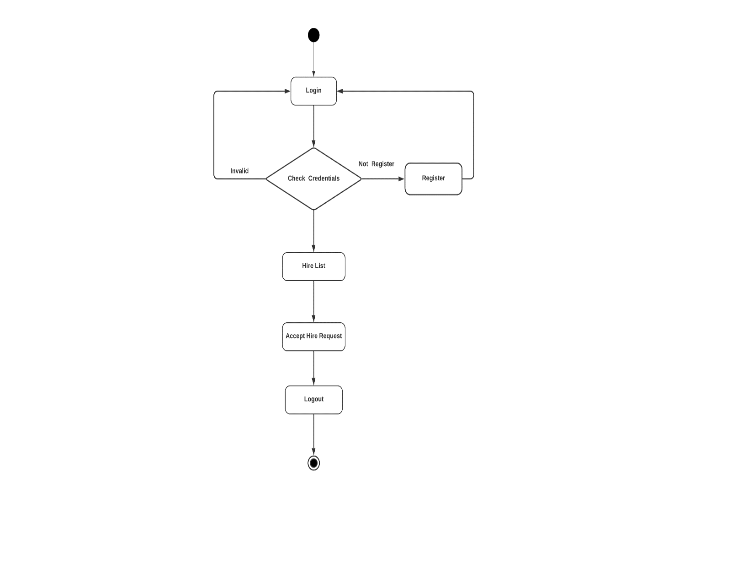

***14***

**Admin Activity Diagram: c.3**

IACSD Akurdi

In House Services

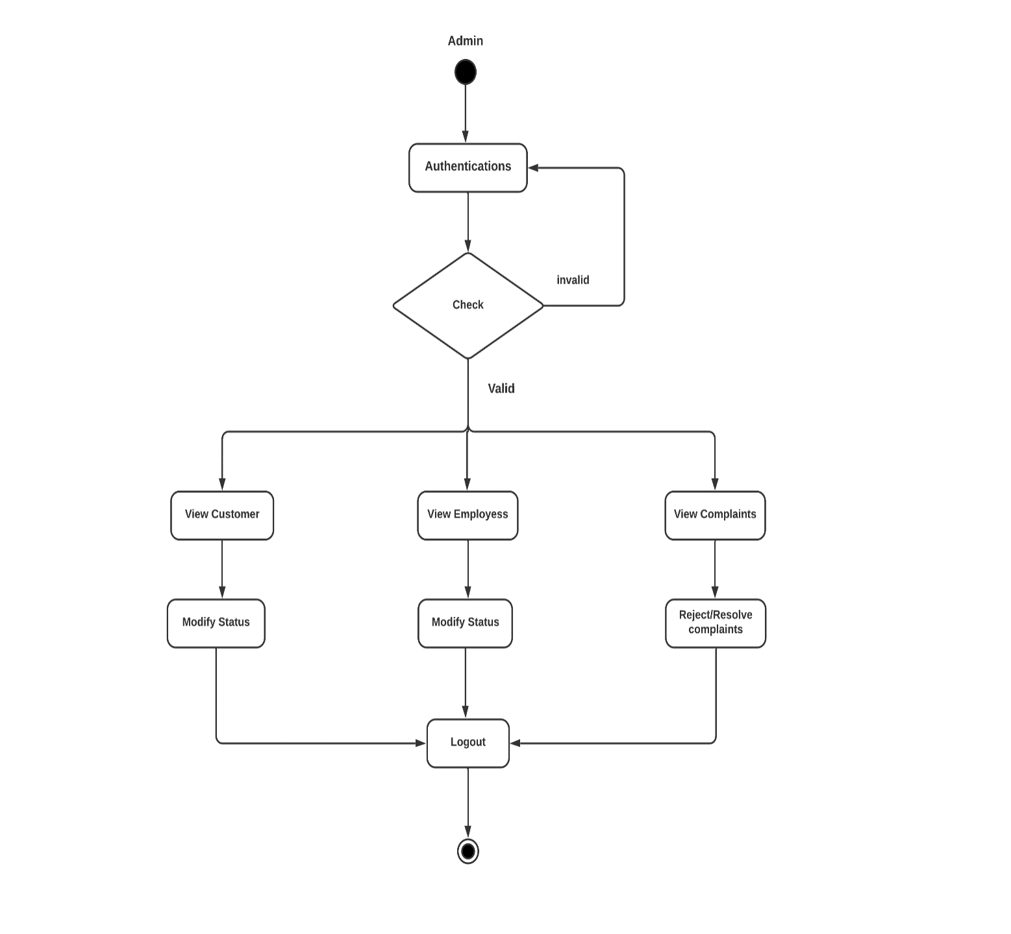

***15***

**Customer Sequence Diagram: d.1**

**c) Sequence Diagram:**

IACSD Akurdi

In House Services

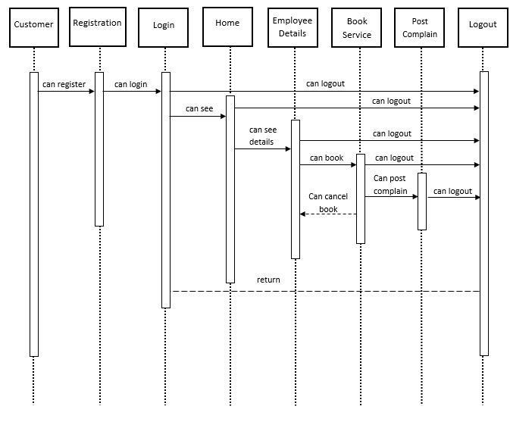

***16***

**Employee Sequence Diagram: d.2**

IACSD Akurdi

In House Services

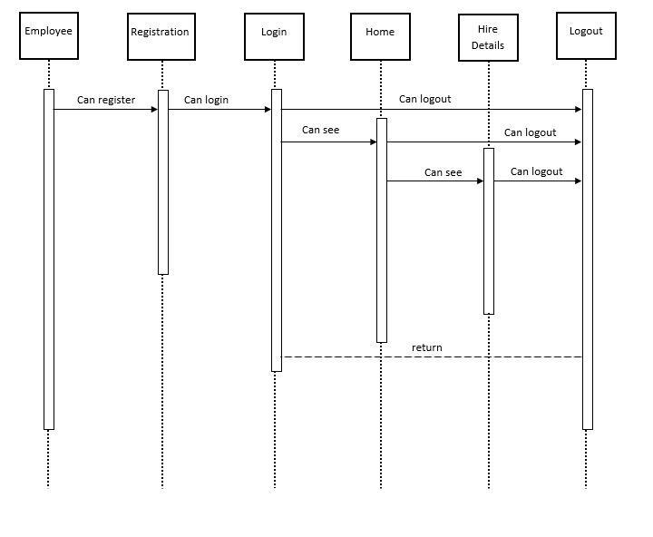

***17***

**Admin Sequence Diagram: d.3**

IACSD Akurdi

In House Services

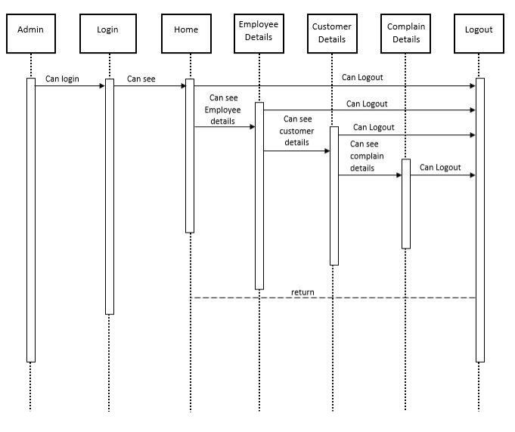

***18***

* **We can add more services to the system.**
* **We can expand this business to the broader level.**
* **Also we can add online payment .**
* **We can enhance the interaction between customers and employees.**

**Future Scope:**

